**Work Item Recognized**

1. Hide (change pass) when profile edit is clicked and vice versa. **[OPEN]**
2. Exam = can be associated with multiple sections (A & C, B & D) but currently we can either select a section or we can select ALL. **[OPEN]**.
3. Script automation **[OPEN]**

Change exam status from OPEN to CLOSE; run script in off hours. Some work started but “kamal” has stopped the work; work on later. Script task will be performed when Admin changes Student section, teacher release exam and student click exam.

1. When release button is hit, populate TEACHER_EXAM_RELEASED. **[Done]**
2. Populate TEACHER_EXAM_ATTENDENCE when teacher release exam **[OPEN]**.
3. Display list of exams to students **[OPEN]**.
4. Populate TEACHER_EXAM_ATTENDENCE when admin add/modify student sections **[OPEN]**.
5. Y

**S/W Manager - OPEN**

1. In case of any obscene questions/answers
2. Can see all Exam Ids (Released Only) and their associated questions.
3. Can activate/deactivate any questions from the exam.
4. Can activate / deactivate any user id (teacher/student)
5. Not manage institute admins id, because admins can not generate obscene.
6. Can manage all drop down
7. Can activate / deactivate all any institute
8. Can activate / deactivate any admins id

**Manage Drop - Downs**

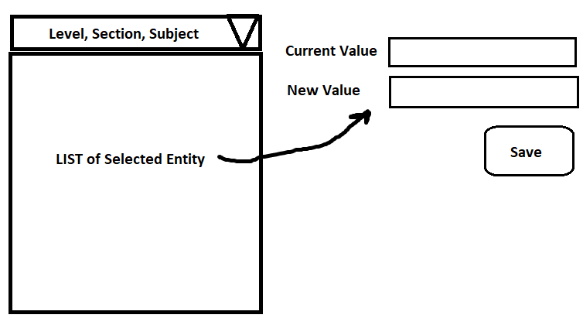

**Manage Institute**

Activate / Deactivate

**Manage Users**

Activate / Deactivate

**Institute Administrator Module – WIP**



**Manage Institute**

1. Can change institute name, owner, contact, institute contact, institute email, country, state, city, address, pin code, institute logo

**Manage Student Button**

1. Add/remove students in his institute / class / section
2. If we display all list of students to admin then admin can contact any student for marketing purpose. My suggestion is that admin must have to enter full string of student user id. If this is not a problem then we can allow admin to search and add student in his institute.

**Manage Teacher Button**

1. Activate / Deactivate teacher id

**Edit Profile (ANY ONE Can do on his own) - OPEN**

* First Name
* Last Name
* Contact1
* Contact2
* Address
* Profile photo

**How Exam will be available to student?**

??

**Exam_released = Table**

Institute_id

Level

Section

Subject

**Student - OPEN**

* When a student is logging then select institute button must be disabled. [Done]
* Students can be associated with multiple institutes. **[Done]**
* Admins of the respective institute can add/remove any student in his institute. **[Done]**

**Dashboard Button**

Display all new exams assign for test

**Notice Board Button**

* All exams will be displayed here, and student can attend it through attend button

Logic for exam selection

Select all institute lists from INSTITUTE_USERs

Select all available exam from these institutes

**Teacher**

|  |  |  |  |  |
| --- | --- | --- | --- | --- |
| **Source**  **FRS/**  **CPY/**  **RER** | **Release Yes/NO** | **Has Questions**  **Qs>0** | **Action** | **Status** |
| FRS | YES | Yes | Disable Release Button  Disable Delete Button  Disable Save Button  Enable Re-Release  Enable Copy | DONE |
| FRS | YES | No | Not Possible | DONE |
| FRS | NO | NO | Disable Release Button  Disable Re-Release  Disable Copy | DONE |
| FRS | NO | YES | Enable Release Button  Disable Re-Release  Disable Copy | DONE |
| RER | YES | Yes | Enable Re-Release  Enable Copy | DONE |
| RER | YES | No | NOT POSSIBLE |  |
| RER | NO | NO | NOT POSSIBLE |  |
| RER | NO | YES | Enable release button | DONE |
| CPY | YES | Yes | Enable Re-Release  Enable Copy | DONE |
| CPY | YES | No | NOT POSSIBLE |  |
| CPY | NO | NO |  |  |
| CPY | NO | YES | Enable release button | DONE |

|  |  |  |
| --- | --- | --- |
| Source | Is released | Action |
| FRS | NO | Delete from question  Delete from option  Delete from marks  **DONE** |
| CPY | NO | if it is existing question then delete from mark only  if it is added question then delete from question, marks, option  solution  get question count from marks  if count is >1 then delete only from marks  if count==1 then delete from all  **DONE** |

**Current Work Marker ==>20-July-2021**

**Student, Teacher, Admin, s/w manager**

* **Add section in reference table**
* **Add section in exam**

**When ALL is selected then that exam will got to all students of that class.**

* **Admin will promote students and define his class/sections**
* **In case of student registration; disable the institute option**

**Administration of the institute will add student in its respective class and section.**

* **Add start time in exam,**
* **end time = duration + start time**

====================================================

1. **Next & previous button in question screen**
2. **Release button on Exam screen**
3. **Question summary popup**
4. **After confirmation release only**
5. **Summary**
6. **Only Question text**
7. **Disclaimer ( kamalji)**

**============================================**

**List of works for work up to 10 Aug 2021**

1. **Student registration [Done]**
2. **Add Exam section [Done]**
3. **Add Exam start time [work]**
4. **Add end time = duration + start**
5. **Next previous button (just add html button– implement the code later) [Done]**
6. **Question summary**
7. **Release confirmation**
8. **Release exam**
9. **Once question is added in exam then you cannot edit or change, level, section, and subject of exam --**

**=🡺write code in Save exam also disable the subject and level dropdown**

**[DONE]**

**Add ALL option in section**

1. **If exam is released then all exam settings (like, Exam Date, Time, level, section, subject, etc) will be disabled.**

**Only the already released exam can be released or can be create a copy.**

**Only exam with questions can be released i.e. exam with 0 questions cannot be released.**

1. **While deleting questions check if it is associated with any released exam or not. If associated then cannot be deleted.**
2. **When the End Date and Time is over of any particular Exam, then a button called “Re-Release” will be appear and few Exam Settings (like, Exam Date, Time, section) will be enabled. This Re-Released Exam will have a different Unique ID. In Release exam we cannot add or delete questions.**
3. **All the Released Questions will never be deleted, only Super Admin can do it.**
4. **Same Question should not be saved with multiple Unique Question IDs. [DONE]**
5. ***Copy Exam Feature*: Everything will be enabled except Class/Level and Subject. Old Question will be displayed but SAVE button will be disabled. If there is/are some change(s), SAVE button will be enabled and Question will be saved with new UID and the reference of old QUID will be removed from concerned Tables like Marks Table, etc. In this Feature, Questions can be edited, old ones can be used, new ones can be created/deleted.**
6. **Print All Questions of an exam on the paper if required**
7. **You cannot add delete question in release exam**

**If Question has Parent exam then that question cannot be deleted or edited.=🡺 then**

//---Display message on question screen that you cannot ADD/DELETE Questions in ReRELEASE EXAM

**ReRelease ===**

1. **only enable Start Date, End Date, Duration, section**
2. **insert all question id in question_marks table.**

[**https://www.oliveboard.in/sbi-po/?ref=GoogSBIPO2021&gclid=CjwKCAjwmK6IBhBqEiwAocMc8p-3U1GQruLA8VOvNsb_XmF9PYKTQ_5xSmWdtuugY1o_haFqi23YDxoCTOwQAvD_BwE**](https://www.oliveboard.in/sbi-po/?ref=GoogSBIPO2021&gclid=CjwKCAjwmK6IBhBqEiwAocMc8p-3U1GQruLA8VOvNsb_XmF9PYKTQ_5xSmWdtuugY1o_haFqi23YDxoCTOwQAvD_BwE)

[**https://gradeup.co/online-test-series/ssc-exams**](https://gradeup.co/online-test-series/ssc-exams)

**ReRelease=**

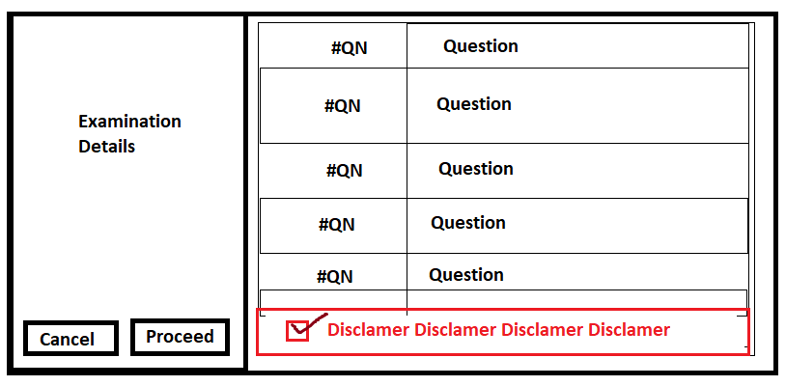

**Disable dashboard, Examination, and Check Answer Buttons**

**Theme, Background & Font of Web - Application**

**Theme:** Black & White

**font-size:** 16px;

**font-family:** Georgia ;

**The Home Page & S/W Portal of Web Application**

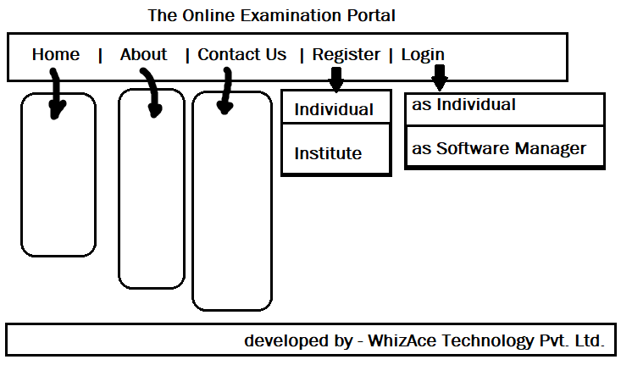

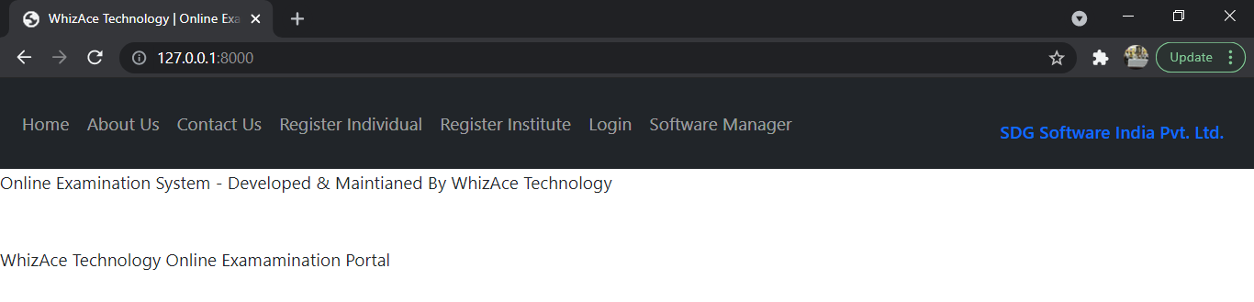

**Register Institute**

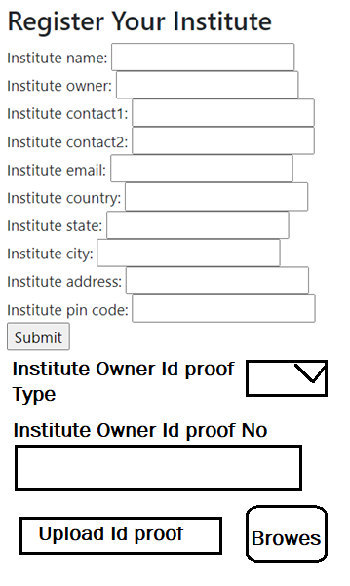

**Rule:** **Once institute is verified & activated by s/w manager then only institute will use this s/w**

**Provide owner document upload button (image upload)**

**Register Individual**

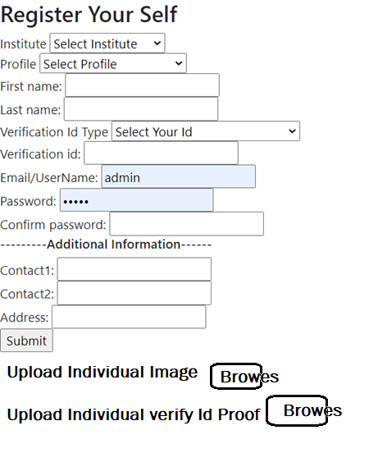

Rule: by default student/teacher created Id will be de-activated; once verified by institute administrator then it will be activated.

Give upload image button to upload his id proof.

Institute administrator is verified by s/w manager.

**Login – as Individual**

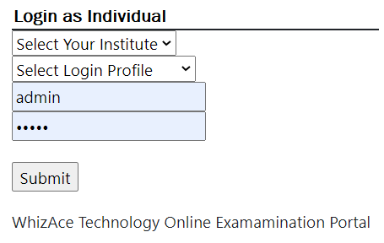

**Login – as Software Manager**

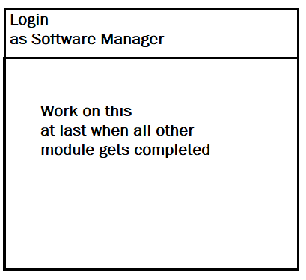

**This is super user without any restriction – only WhizAce Technology.**

**It can delete any institute, institute admin, teacher, student, exam, question etc.**

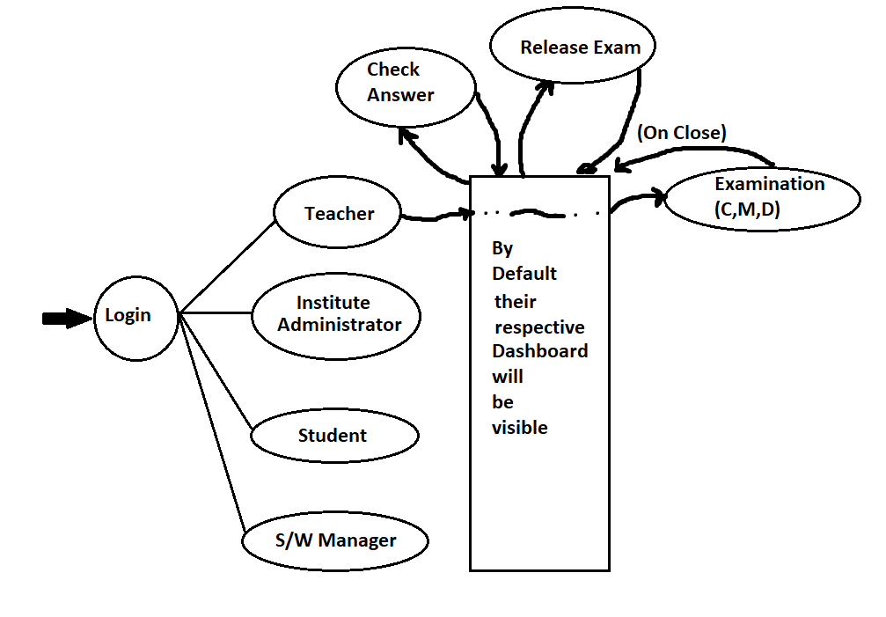

**Login – as Teacher**

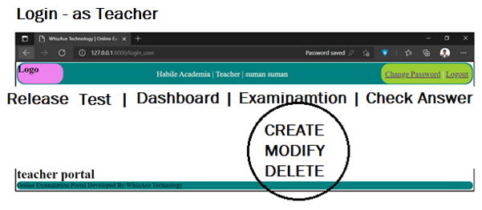

**Dashboard 🡪 all info summary; exam wise student’s marks**

Default display is dashboard

**Examination Module**

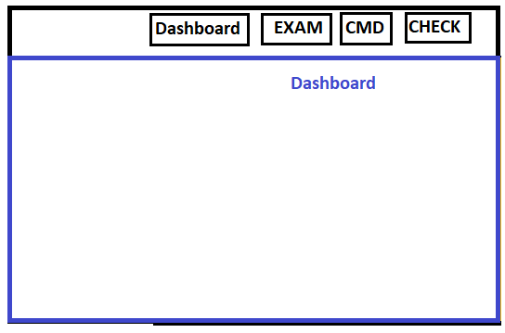

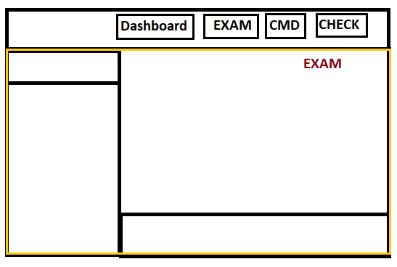

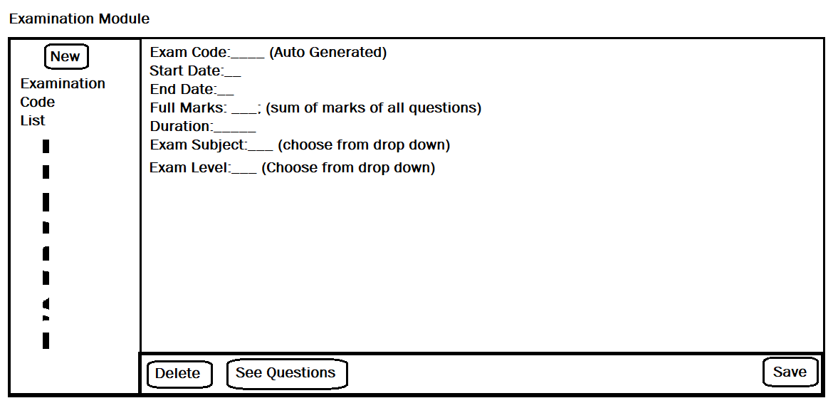

**Exam Code:** will be auto generated – also will be provided by KAMALji

**Exam Start Date:** set by teacher

**Exam End Date:** Set by teacher (this must be a future date from start date)

**Exam Duration:** must be entered by teacher

**Exam Subject:** Will be entered by teacher from drop down;

MATHEMATICS, GK, History, Geography, English, Indian Polity, Biology, Computer Fundamentals, Economics, Current Affairs,

Physics, Chemistry,

**[these subjects will be entered by s/w manager]**

**Full Marks:** sum of (marks of all question belongs to this exam)

**Examination Level:**

Once exam level is assigned then students belong to that class will get that exam.

Class01, Class02, Class03, Class04, Class05, Class06, Class07, Class08, Class09, Class10, Class11, Class12, Medical Entrance, SSC, IBPS, BANK PO, IIT, Railway, Engineering Entrance, etc.

**Marks will be at ExamId+QID**

**Examination Module**

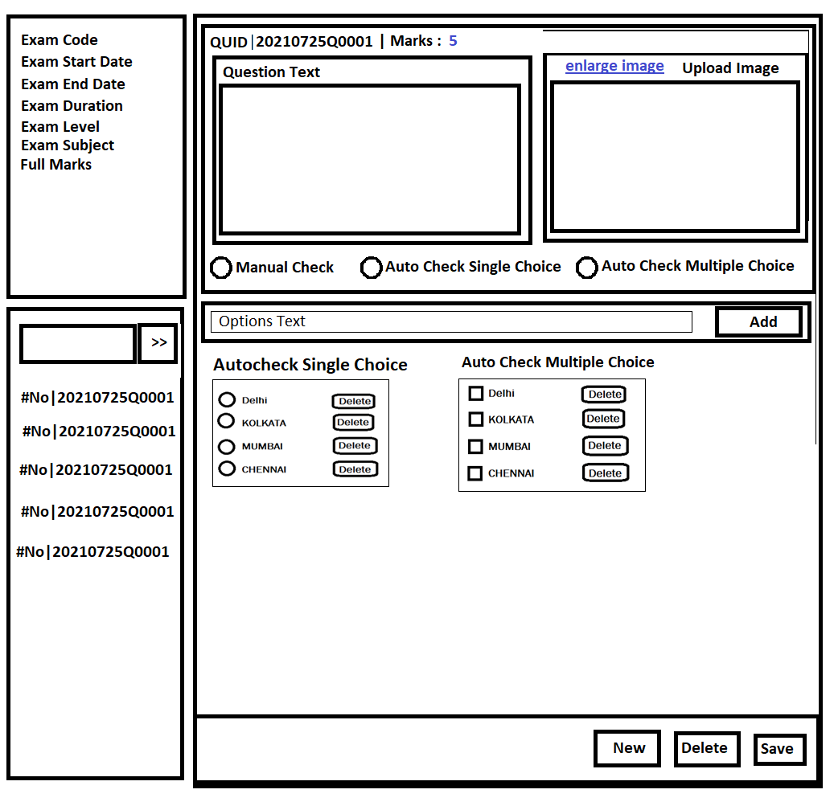

**In case of deactivate question – when we copy give deactivated message**

**And you can not release any new exam with deactivated question.**

**When change qtype, then delete all available options – confirmation box**

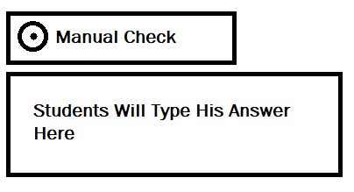

**In case of Manual Check – Question setter (teacher) has not to do anything, only student has to enter answer.**

In case of auto check “Teacher” must have to select the correct answer before saving the question.

Future provision in question [discuss with kamal]

1. Provide image options
2. Add feature to provide matching questions

**Student Portal**

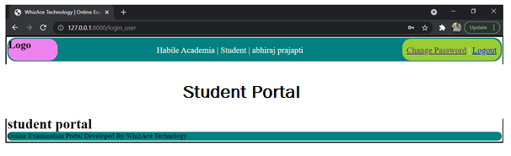

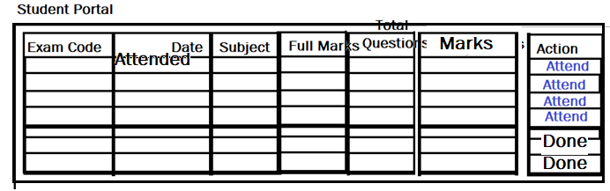

**Check Progress** Button

Show some graph here

**Subject**

**Exam code**

**Start date & end date**

**===student class promote**

**admin**

**Exam Attending Portal**

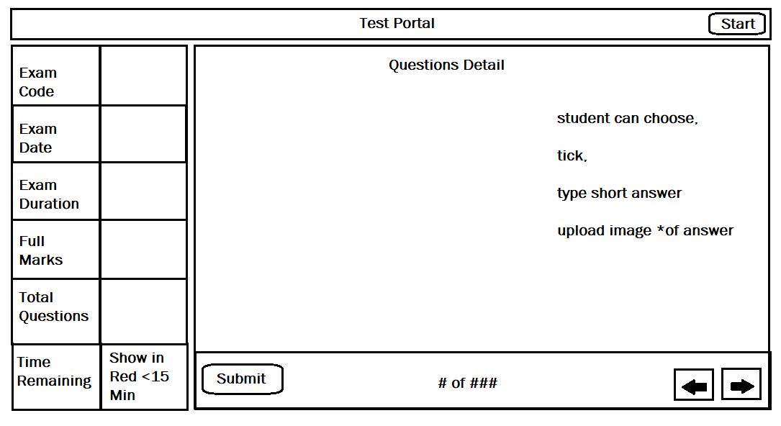

Alerts

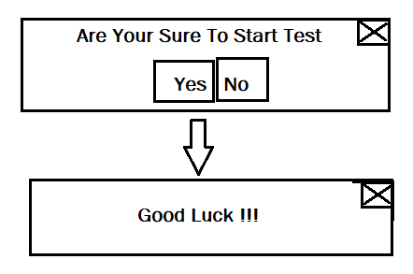

Submit Test at any point of time (give alert to student before submit)

Note: exam will be submitted automatically as and when time is lapsed.

Search the logic for it

**S/W Manager**

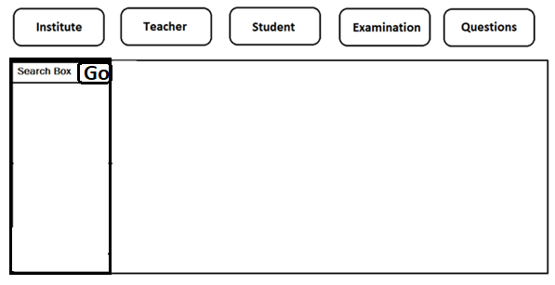

Search Box: Type Keyword and hit enter, results will be shown as list. In this box you can type:-

* Institute
* Teacher
* Student
* Examination
* Questions

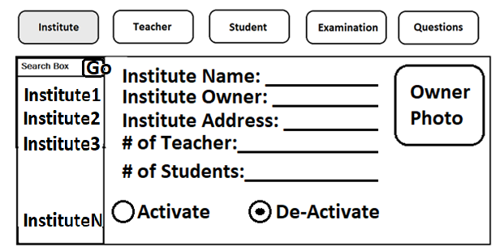

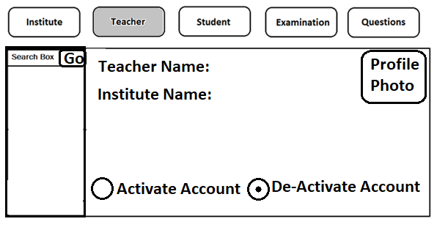

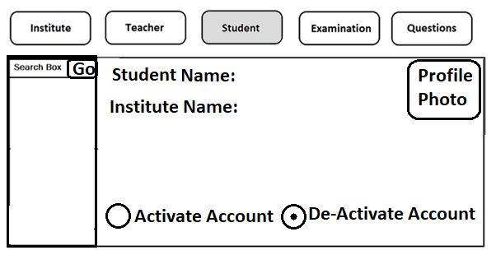

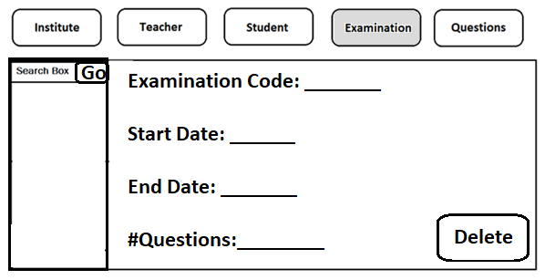

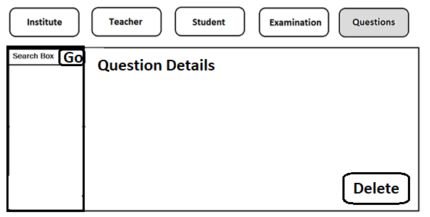

**Institute Administrator**

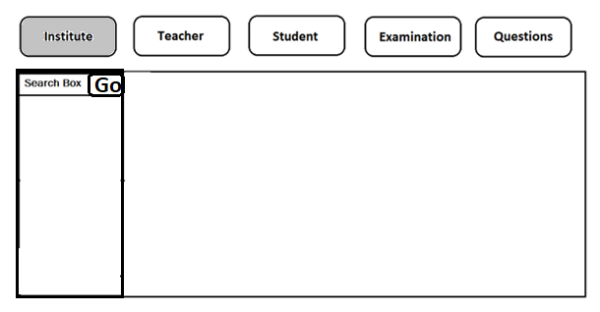

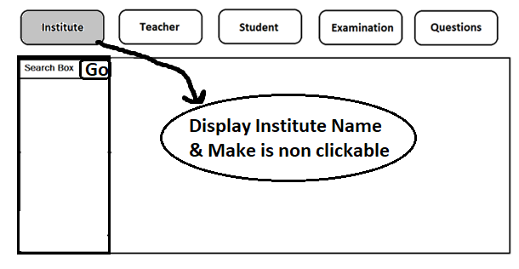

Search Box: Type Keyword and hit enter, results will be shown as list. In this box you can type:-

* Institute
* Teacher
* Student
* Examination
* Questions

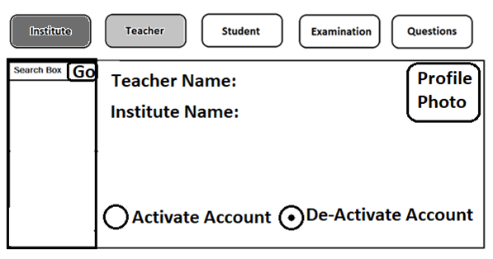

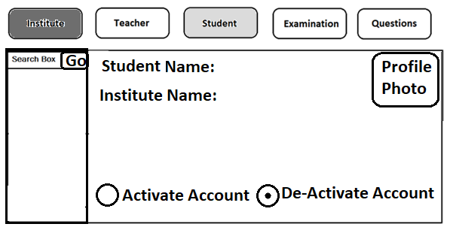

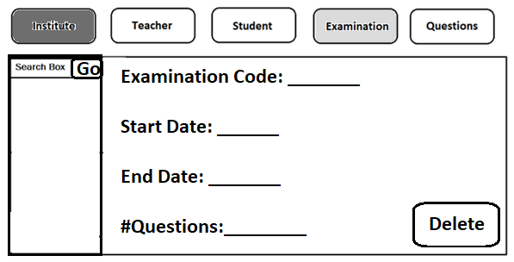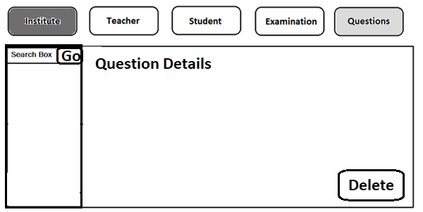

**Business Rules**

* **How exam will be assigned to the students?**
* Once exam is assigned to students teacher cannot make any changes in the exams or exam’s questions are allowed; so that every students get same questions.
* **Copy exam’s** **and all questions,** verify/review it and then save it. In the copied new exam teacher must have to set the start date and end date
* Teacher/can delete exam only if it is not released to student.
* Institute owner can cancel any exam at any point of time.
* From release exam-teacher can verify exam & its question and finally can release exam to the student.
* Only the released and active exam (system date must be between start date and end date) visible to students
* If date is passed whenever some is trying to login in that exam, EXAM_STATUS field must be showing EXPIRED.
* If all questions of and EXAM are automatic then check by computer otherwise if any (single) question has manual question then teacher must have to check and give his marks for that student.
* Institute admin can delete any exam wheteher passed, ongoing , ,,,
* If exam is released and some students has attended it then no modification is allowed. If you modify after attending then next student will get modified questions.
* Institute Admin can extend the end date of exam, but only before the end date expiry.
* How can we assign a particular exam to a student?

Ans– using exam level

* Whether teacher will select class or students for assigning the test. – Ans: yes
* If teacher assign a particular exam to a class then all the students of that class will have to attend the test.
* Institute owner can activate and de-activate any of his teacher or student

**[Need to discuss with kamal– added on 27-Jun-21]**

* Each question is associated with teacher’s Id
* Each student will be associated to his answers
* Provide image upload button to student for image upload
* Can see all available exams with expiry date
* Can see all passed exam, full mark his scored in that exam.
* Can see his progress graph based on date and score.
* If a teacher had posted any offensive questions then institute admin can de-activate the teacher’s account.
* Institute admin can delete any exam/questions.
* s/w manager has all access without any restrictions.
* Institute admin can delete any student.

**Kamal’s Feedback**

Register Institute

1) inpute 'Institute Website' also.

2) ID Proof should be optinal not mandatory.

3) Option to upload 2 Photos (one of Institute and the other of Owner) - uploading of one Photo is mandatory.

Register Individual

1. ID Proof should be optinal not mandatory.

**WIP**

**Approach2**

**Question Bank Module**

**Question Level – Drop Down (select Question Level) – this will be addred**

Class01, Class02, Class03, Class04, Class05, Class06, Class07, Class08, Class09, Class10, Class11, Class12, Medical Entrance, SSC, IBPS, BANK PO, IIT, Railway, Engineering Entrance, etc.

**Question Subject (select Question Subject)**

MATHEMATICS, GK, History, Geography, English, Indian Polity, Biology, Computer Fundamentals, Economics, Current Affairs,

Fundamental Science (Up to Class X), Physics, Chemistry, Miscellaneous, etc.

**Question Mark (?)**

Display Input Box for entering the marks only at the time of exam creation not at the time of question creation. – confirm it

Or we can enter question marks at the time of question entry.

**Auto Field per default only uses positive numbers, so the values can go from 1 to 2.147.483.647. [info – ask kamal if need for code]**

**Each questions will be associated with the Institute.**

**Questions can be associated with any Exam at any point of time.**

**A question can be edited at any point of time if and only if 🡺 Question is not associated with any active exam.**

**Create logic for question edit – confirm this with kamal.**

**is it logical if a question is released in exam and some students has attended the exam then could we edit the questions.**

**If a teacher has checked students answer then can he re-check the question this means question edit is not possible.**

**Get business logic clear from kamal**

**Can any student ask for review?**

**If yes then question edit is not possible**

**As per kamal, question edit is not possible if it is associated with any exam.**

**Absument type question**

**Improvement**

**When you click EXAM_CRUD**

1. **Load all exam id**
2. **Now search box using jQUERY**

**When you hit save then also load all list**